Sarah Dubbert, Scott Howard, Joshua Koni, Mathewos Keller

Group 6

Design Prototype Images and Descriptions

**Northland - New Site**

Home Page

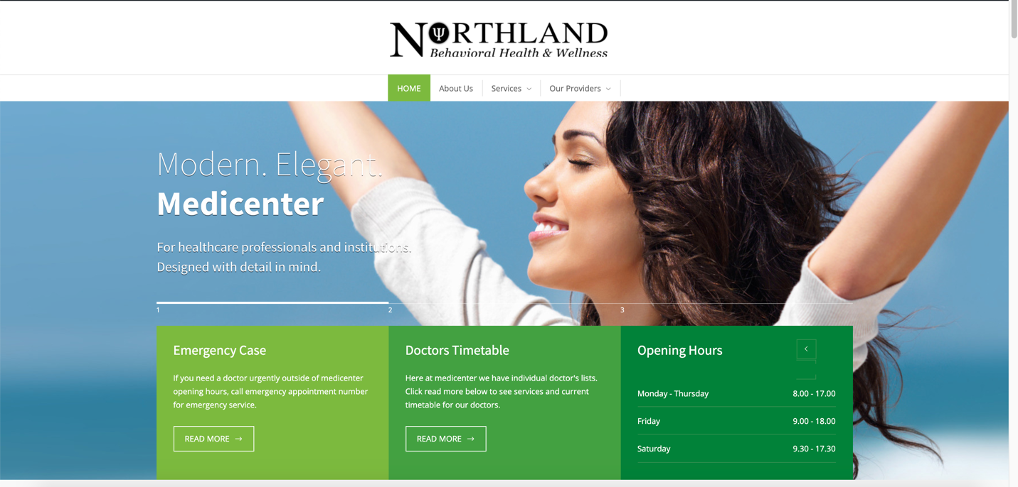

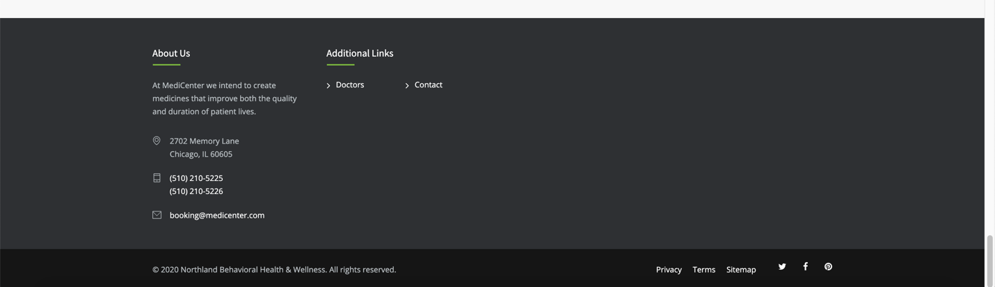

* We hope to invoke welcoming, warm, and inviting feelings
* The site header is simple and allows for easy and intuitive navigation
* The logo is placed centrally on the top of the screen, in line with the header below
* We are using white and grey colors, and shades of green as our accent colors
* The home page will have the different services displayed so that those pages are more accessible
* The footer provides all necessary contact information

About Us Page

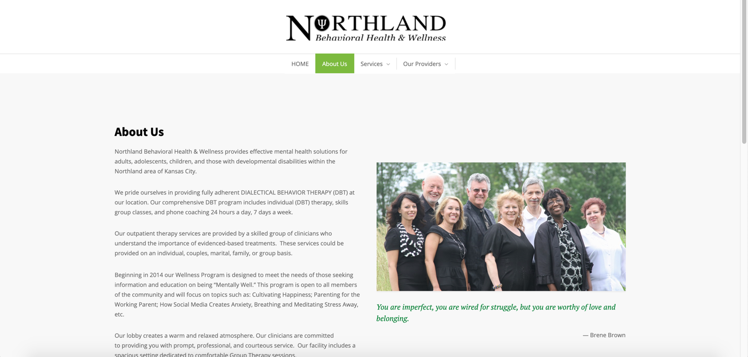

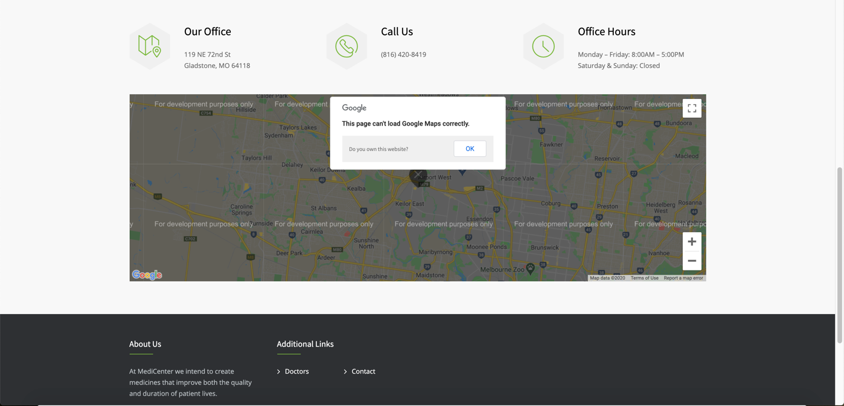

* The green accent color provides some warmth and color to the page
* The information is displayed simply
* The location is displayed on Google Maps for easy accessibility

Services Page(s)

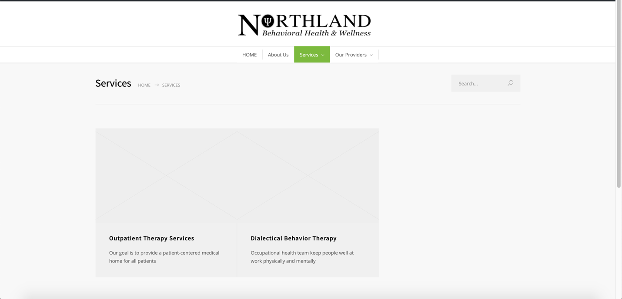

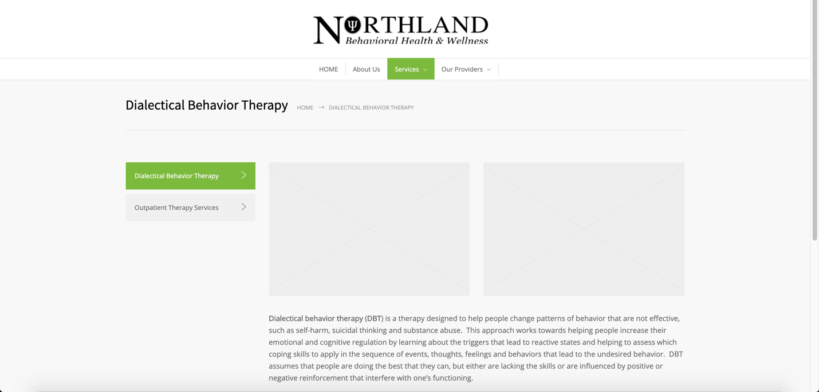

* There is a Services home page, as well as an individual page for each service
* The services menu on the left allows the user to easily switch between services
* We will be adding warm and inviting photos to complete the pages

Providers Page

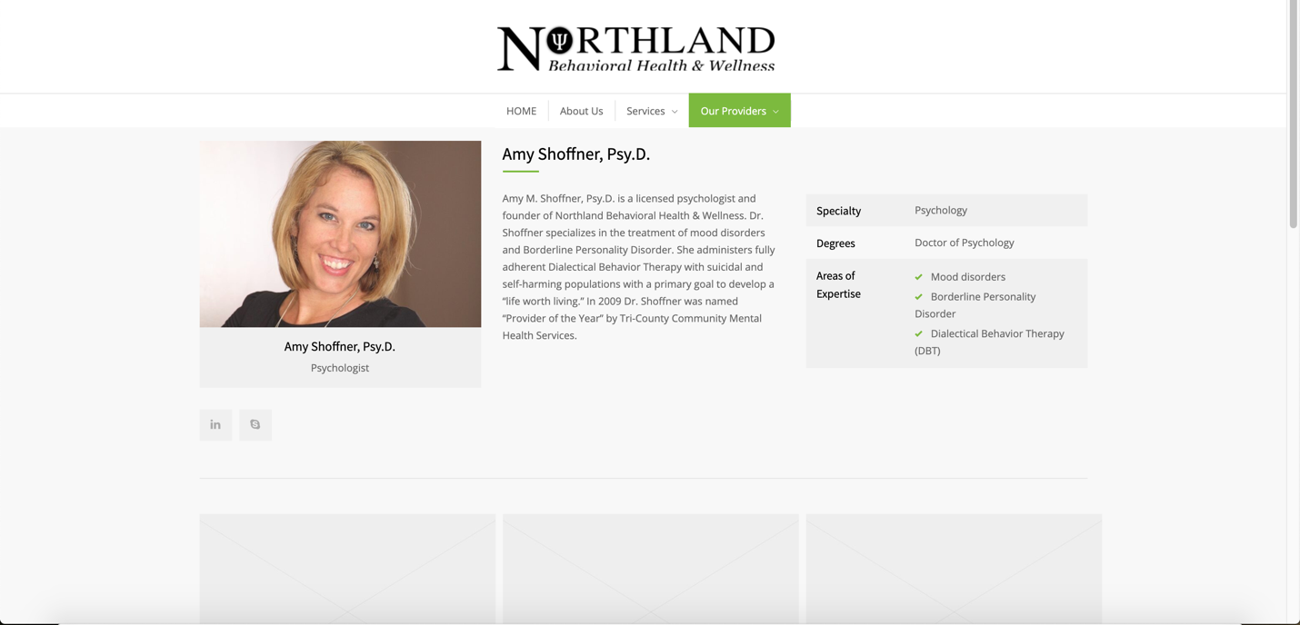

* Each provider's information is displayed with a photograph, bio, and a table with other necessary information
* The contrast between the white/light gray backgrounds provide a balance to the page and help the user differentiate between sections